4 Channel Bipolar Power Converter Chassis Test Guide

Note: This document is meant to be used only as a guide to test document '4 Channel Bipolar Power Converter Chassis Production Test Procedure (Inspection, Setup, Electrical, Functional, and Performance Testing)'. All test results should be entered to a copy of that form. This document is not a test procedure.

Prerequisites:
- Test conductor is familiar with power converter and chassis design.
- Test conductor has received training on this test procedure and is familiar with what the test results are expected to look like.
- Chassis undergoes EEI inspection upon receipt from vendor before AC power is applied.

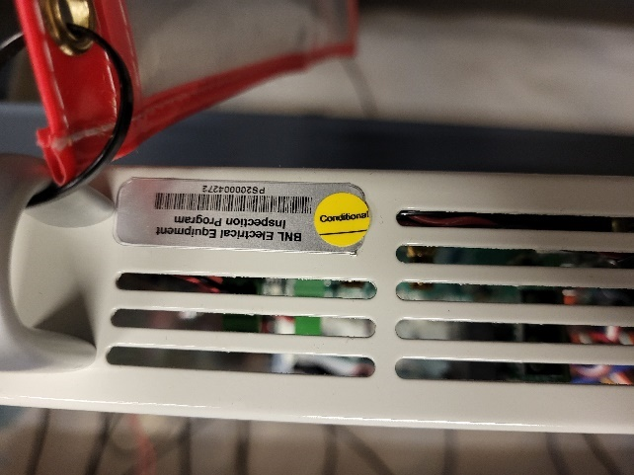
fig. 1 EEI sticker

- 208 VAC input section is draped when testing with AC power on and chassis top cover off.
- If any inspection or test step gives wrong result, abort inspection/test procedure, segregate chassis, and inform EEG group.
Need Python and Arduino IDE loaded on PC, hypertermdib.py and python files hyperUDPdib.py and alsu2chan.py. Also need the config.txt file for the SD card.
Note that the test procedure describes the steps needed to test one half of the power converter chassis. The test steps below should be carried out for both left (CH1) and right (CH2) halves of the power converter chassis. Place a check in the box after completing test step for both channels.

- Visual Inspection (chassis top cover off, no AC power):

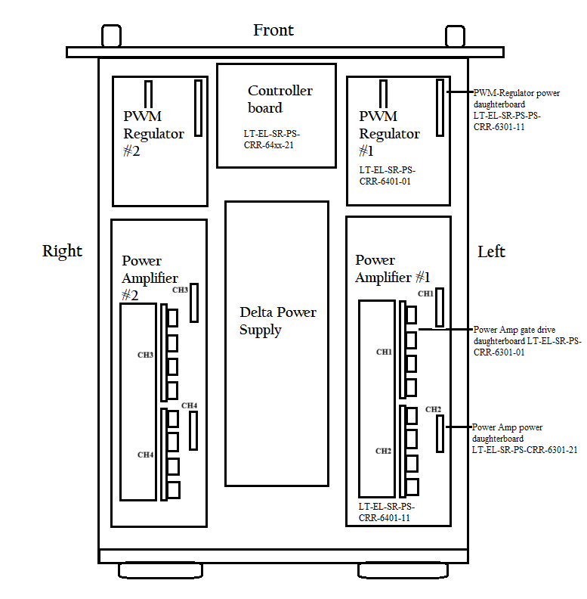
Fig.2

- Power entry module 208 VAC fast-on connectors are shrouded type and that they’re properly mated to the tabs on the power module, (i.e., tabs are slid into slot in connector - not squeezed between the metal and plastic).

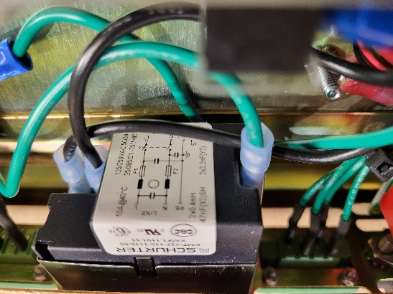
fig. 3

- 208 VAC terminal block on Delta power supply has plastic slip-on finger guard in place.
- 208 VAC terminal block on Delta power supply middle terminal is connected to green ground.
- Delta power supply module connectors CN102 are well seated.

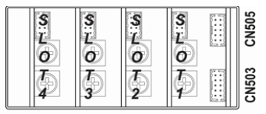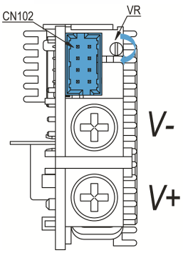
fig. 4

- Six cables from Delta power supply to controller board are plugged into the right connectors –

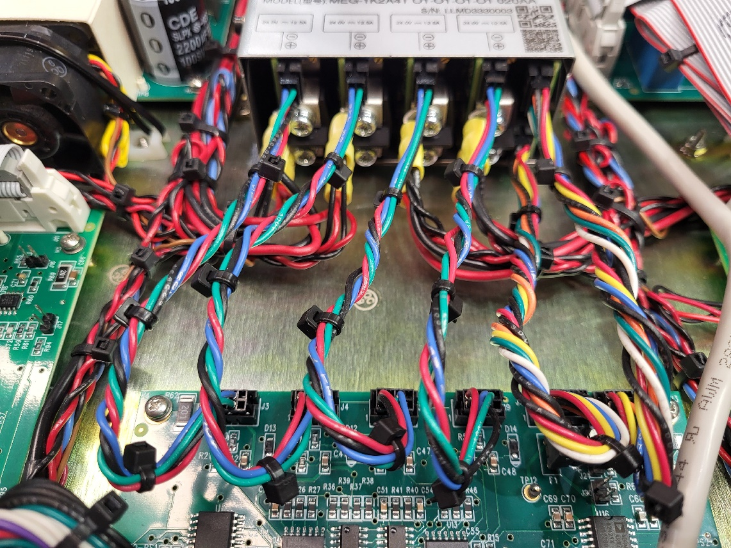
fig. 5

Controller Delta
J3 slot 4
J4 slot 3
J17 slot 2
J19 slot 1
J7 CN503
J8 CN505

- +24 V wiring polarity is correct for 16 AWG connections to power amplifier board (LT-EL-SR-PS-CRR-6401-11) terminals J3 and J7. J3 is ‘DC IN HI’ (red wire), J7 is ‘DC IN LO’ (black wire). On the Delta power supply the black wire is on top and the red wire is beneath it.
- +24 V wiring polarity is correct for 22 AWG connections to power amplifier (LT-EL-SR-PS-CRR-6401-11) power daughterboards (LT-EL-SR-PS-CRR-6301-21); there are two on each power amplifier board. Check the red and black wire orientation: The black wire should be at the top. Also, check insertion of daughterboard pins into its socket on the PWM-Regulator board. Make sure it’s not loose due to undersized pins.
- +24 V wiring polarity is correct for 22 AWG connections to PWM-Regulator (LT-EL-SR-PS-CRR-6401-01) power daughterboards (LT-EL-SR-PS-CRR-6301-11); there are two on each power amplifier board. Check the red and black wire orientation: The red wire should be at the top. Also, check insertion of daughterboard pins into its socket on the PWM-Regulator board. Make sure it’s not loose due to undersized pins.

- Power amplifier board electrolytic capacitors are installed correctly on PCB. The negative side (-) of all four caps should be facing toward front of chassis as shown in figure 6.

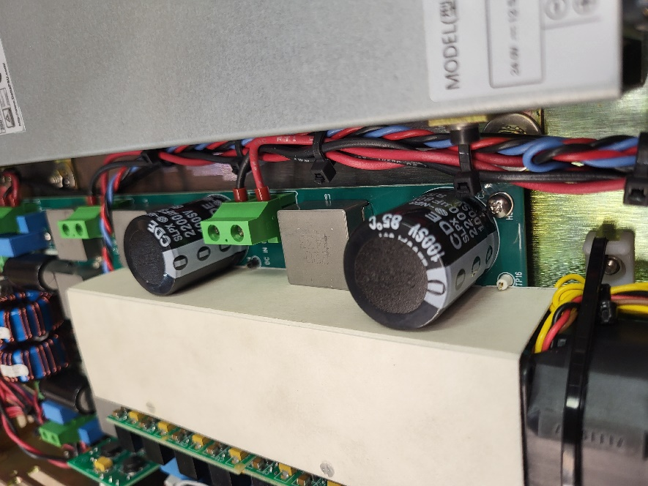
fig. 6

- Power amplifier gate drive daughterboards (LT-EL-SR-PS-CRR-6301-01) are installed.
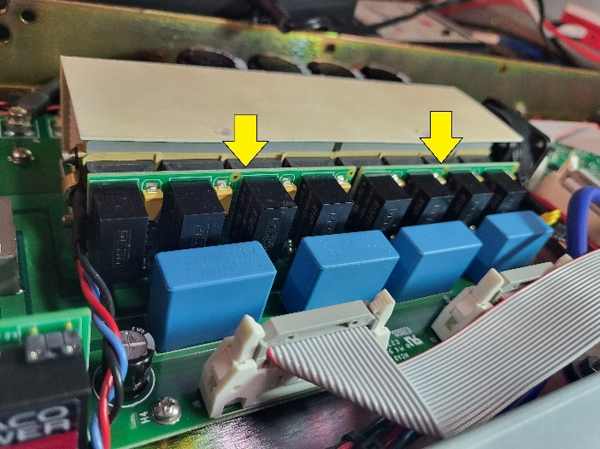
fig. 7
- PWM-Regulator power daughterboard white test points and Controller board TP12 and TP14 do not read short to ground.
- Power amplifier +24 V DC bus does not measure shorted with an ohmmeter between terminals at J3 or J7.
Capacitance at J3 or J7 with leads removed is around 2200 uF.
- Fused +24 V wiring polarity is correct for fan connector J1 on PWM-Regulator board.

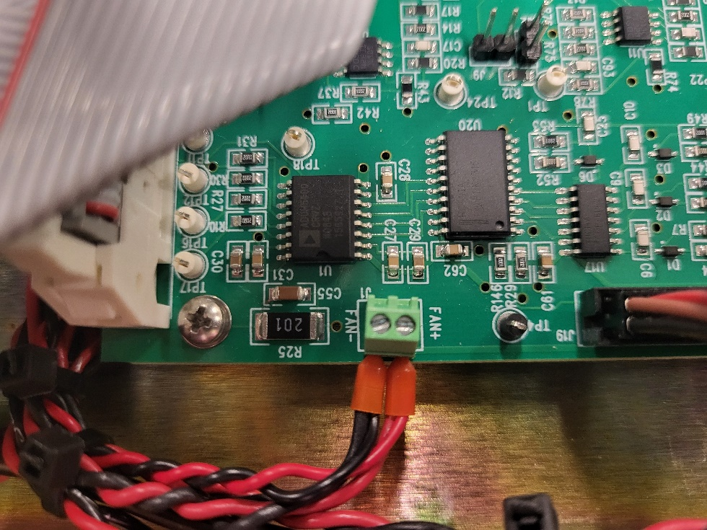
fig. 8

- Fans are facing with brass bearing visible and facing toward the front of the chassis, (figure 9).
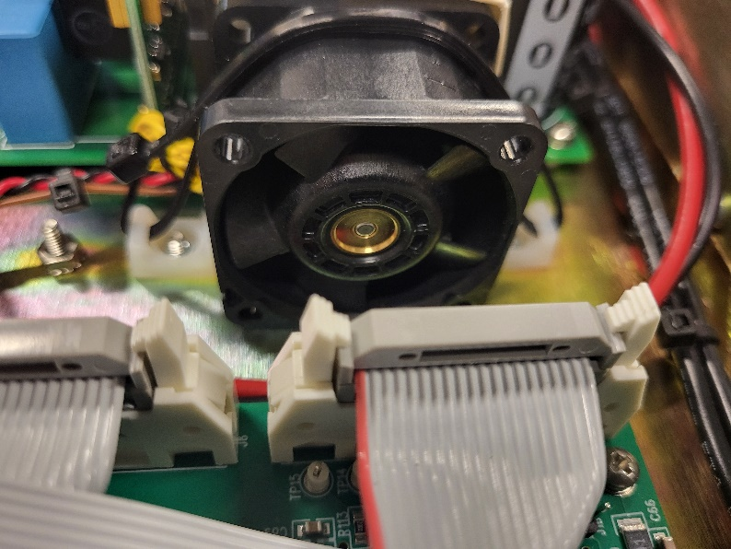
fig. 9

- Wiring polarity is correct for voltage feedback twisted pair connection between power amplifier board J5 (and J11) and PWM-Regulator board J10 (and J23).
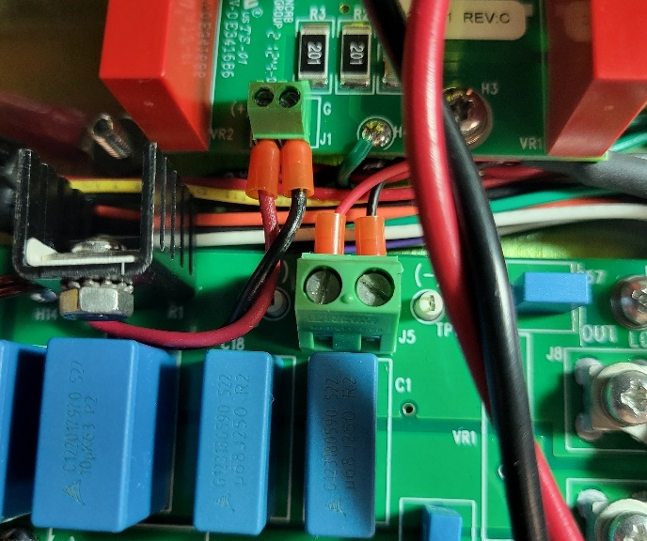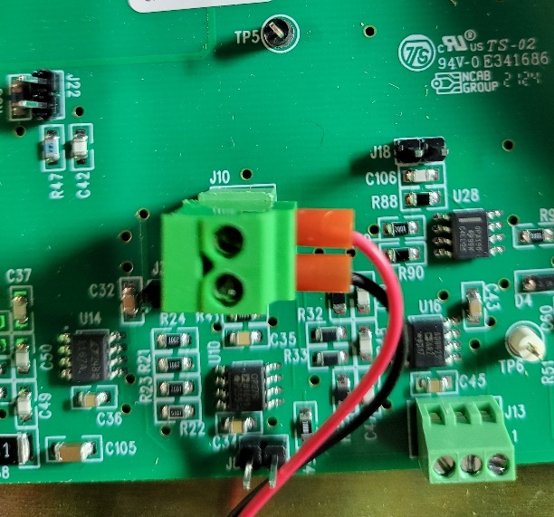
fig. 10 fig. 11

- PWM-Regulator board jumpers shunts are installed correctly according to the following table.
Ref. Designator | Installed | Not Installed | Function
J15 |  |  | HALL1A Current feedback
J9 |  |  | HALL2A Current feedback
J17 |  |  | HALL1B Current feedback
J12 |  |  | HALL2B Current feedback
J14 |  |  | HALL1A Current feedback gain bypass
J2 |  |  | HALL2A Current feedback gain bypass
J16 |  |  | HALL1B Current feedback gain bypass
J7 |  |  | HALL2B Current feedback gain bypass
J4 (J25) |  |  | 1 MHz clock
J18 (J24) |  |  | -2.5 V gain bypass
J8 (J22) |  |  | Voltage feedback
J3 (J20) |  |  | PID voltage loop gain bypass

- PID output 3-position screw terminal block J13 (and J26) have a jumper installed.
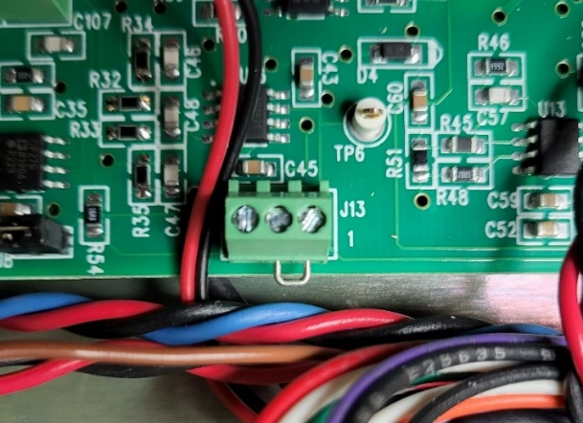
fig. 12

- Ethernet cable is installed.
- Ribbon cable installed between PWM-Regulator board J11 and power amplifier board J6.
- Ribbon cable installed between PWM-Regulator board J6 and power amplifier board J2.
- PCB mounting screws are tight.
- 12 AWG wire connections are tight.
- 10 A fuses are installed in 208 VAC power entry module.
- 1-wire sensors are attached to heatsinks and wired correctly to screw terminal block J2 on controller board (LT-EL-SR-PS-CRR-6401-21). Verify that the wire colors match the order shown below: Black (GND), red (+5V) then blue (DAT).
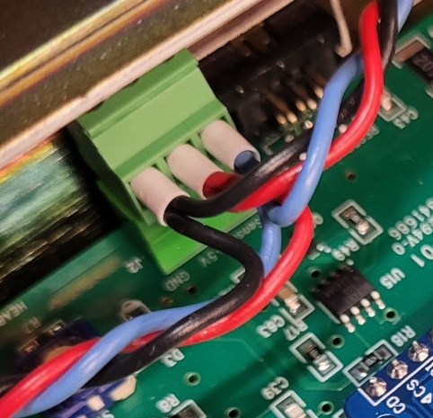
fig. 13

- On the two power daughterboards (LT-EL-SR-PS-CRR-6301-11) for each PWM-Regulator board, U1 has RS6-2415D part number.
- Verify that the heatsinks for each channel have a 10 kΩ connection to chassis.

- Microcontroller Programming (chassis top cover off, no AC power)
Note: Make sure there’s no SD card loaded into the Controller Board yet, else remove the card.

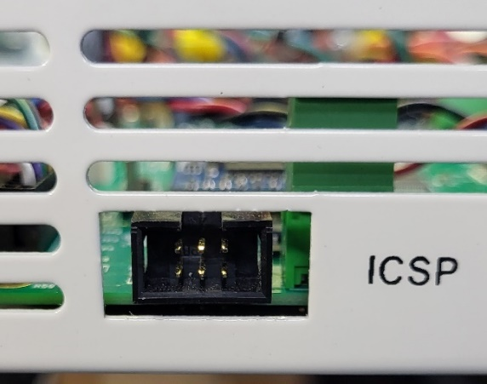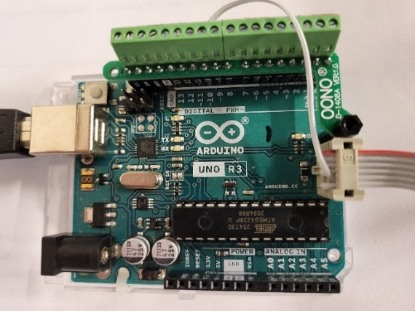
fig. 14 fig. 15

- Burn the bootloader in Arduino IDE
- Open the Arduino IDE program.
- Connect the programmer board to the computer. Connect Arduino UNO to ICSP port on front of chassis, Control board LED D8 should light. At the bottom right see -
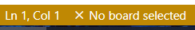

- Select your programmer board in Tools > Board, for example Tools > Board > Arduino AVR Boards > Arduino Mega or Mega 2560. See at bottom right –
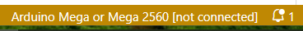

- Select the port the board is connecting to in Tools > Port. Select the port with (‘Arduino Uno’) after it. Now see –
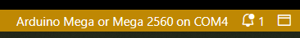
Note: If the Arduino UNO has not been programmed to be a programmer yet, perform the following step. Otherwise
proceed to step 5.

4a. Open File > Examples > 11.ArduinoISP > ArduinoISP.
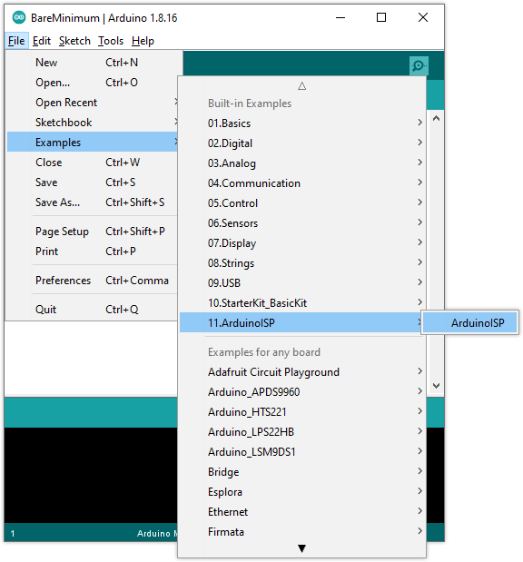
fig. 16
4b. On the new window that comes up, click Upload to upload the sketch to the board. At this point the UNO is
a programmer and will power up with these settings unless a different example is loaded
- Under ‘Tools’ set the Processor as ‘ATmega2560 (Mega 2560)’. ‘ATmega2560’ is the main IC on the Controller board. The ‘Tools’ should show you the COM port that the IDE is using.
- Select Tools > Programmer > Arduino as ISP (ATmega32U4). Under ‘Tools’ you should see something like this –
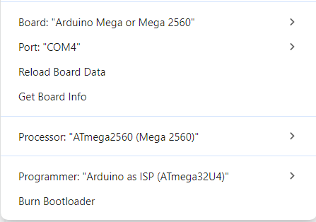
It may be necessary to re-select the Programmer as “Arduino as ISP (ATmega32U4”) to avoid getting “No programmer found” error when burning bootloader.
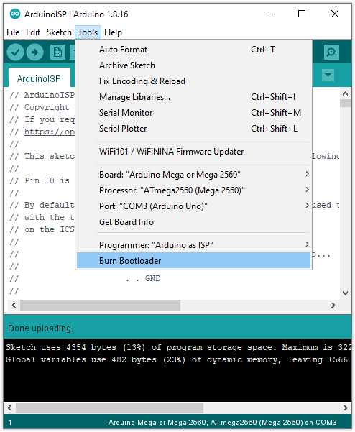
fig. 17

- Burn bootloader through ICSP connector with Arduino programmer (on monitor, click on raspberry icon at upper left corner of screen → ‘programming’ → ‘Arduino IDE’ → Tools->Burn Bootloader).
- Wait for the process to complete, which may take up to a minute. When it’s finished, the message “Done burning bootloader” will appear on top of the console, or in a bottom-right notification pop-up, depending on your IDE version.
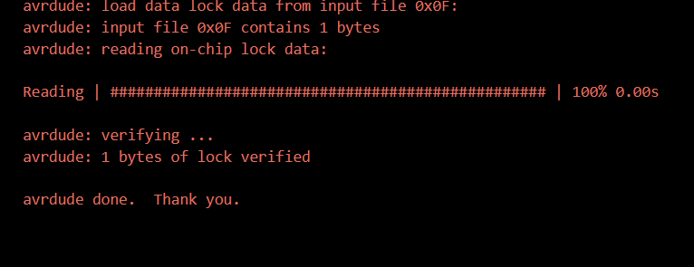
fig. 18

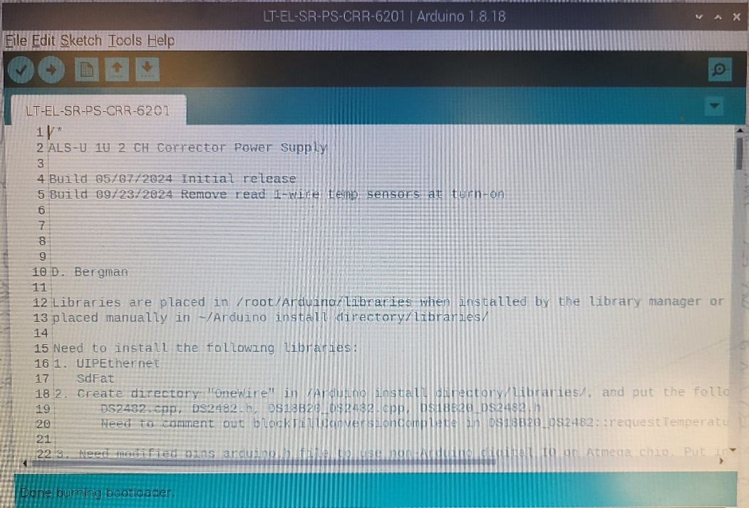
fig. 19

- Program Microcontroller through ICSP connector with Arduino programmer (Sketch->Upload Using Programmer). When done, on the Controller board see green LED D8 and amber HEARTBEAT LED lit.
Unplug Arduino from ICSP jack.
- Insert a microSD card into the microSD to USB adapter after which a message window should appear to ‘Open in File Manager’. Hit ‘OK’ –

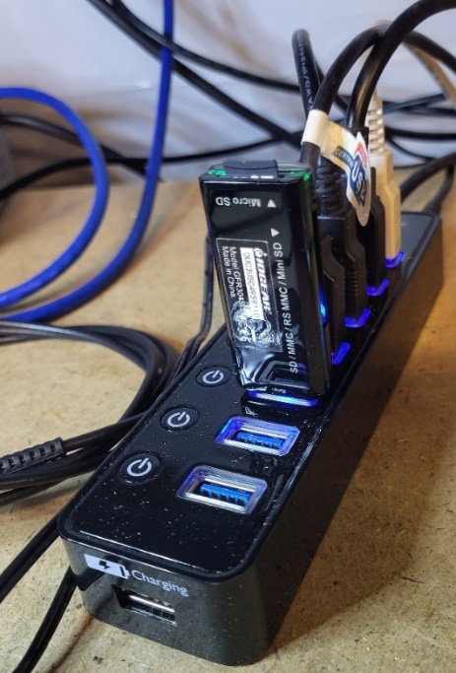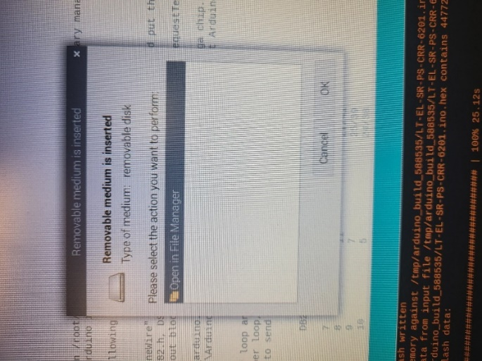
fig. 20 fig. 21

You should then see the directory /media/dib/15GB Volume with nothing in it. Then find or go to another window to find /home/dib/2ch. In it find config.txt. Click and drag this icon back over to /media/dib/15GB Volume to make a copy of it. On separate PC, add file “config.txt” to SD card with information in the format below (a template config.txt file is available in /home/dib/2ch/):
  - IP Address: 192.168.0.y where y is the serial number of the unit, (add no extra zeros, i.e., if serial number is 0005, just enter a 5).
  - MAC Address: 02,00,00,62,0x,y where x is either 1 or 2 for slow and fast, and y is the serial number of the unit in hexadecimal (base 16) representation.
  - 1-Wire Sensor Left: 28,00,00,00,00,00,00,00
  - 1-Wire Sensor Right: 28,00,00,00,00,00,00,00
  - HALL sensor gain: 1.02, 1.02
  - Model.Serial Number: 620x00y where x is either 1 or 2 for slow and fast, and y is the serial number of the unit, (this should also be updated).
- Insert SD card into SD module on controller board –

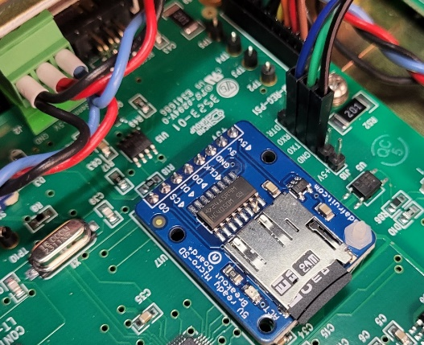
fig. 22
C. Initial Checkout (chassis top cover off, AC power ON)
Controller Board Checkout
Note: At this point make ensure that an ethernet cable is connected to the ethernet jack on the power converter.

- Remove fuses F1 and F3 from both Power Amplifier Power daughterboards (LT-EL-SR-PS-CRR-6301-21), then plug the daughterboards back into the Power Amplifier board. Also, check insertion of the pins of each of the two daughterboards into the sockets on their Power Amplifier board. Make sure that they’re not loose due to undersized pins.
- Remove SiCFET gate drive daughterboards from power amplifier boards. Check insertion of daughterboard pins into its socket on the Power Amplifier board. Make sure it’s not loose due to undersized pins.
- Remove fuse F1 from controller board (LT-EL-SR-PS-CRR-620x-21).

Step | D9 | D8 | D7 (HEARTBEAT)
34 | ON | OFF | OFF
37 | ON | ON | BLINKING

- With 208 VAC section properly draped as shown below, apply AC power to chassis, and verify with a DMM that there is +5 V power at controller board fuse F1 socket. Measure the fuse holder socket near the ‘F1’ marking on the board, toward the rear of the chassis. Use TP9 or TP10 as circuit common reference. If DMM reading shows -5 V, stop test, and correct wiring error. Note: Fans will be running at full speed during this step.
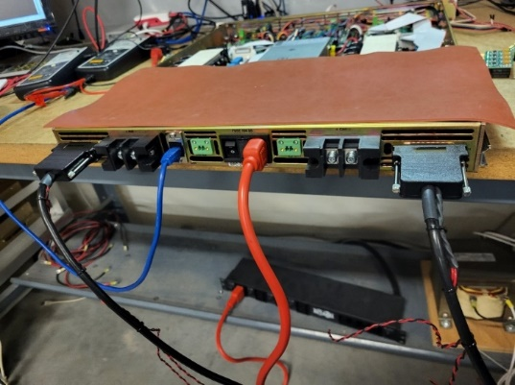
Fig. 23
- Turn off AC power, install fuse F1. Ensure that an ethernet cable is plugged into the back of the chassis then turn the AC power back on.
- Verify 3.3 V at TP11.
- Verify that amber LED D7 (heartbeat) on controller board is blinking.

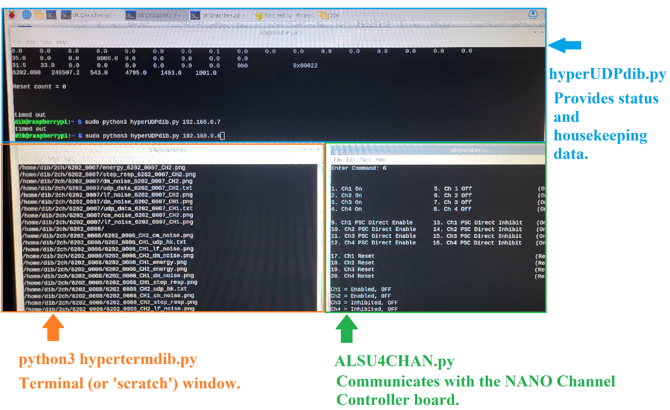

- In separate terminal window on the workstation computer, run the housekeeping data monitor program by typing sudo python3 hyperUDPdib.py 192.168.0.y where y is the serial number of the unit under test.

- Connect USB-TTL-Serial adapter to controller board J18 header, (black wire to GND pin, green to TXD and blue to RXD).
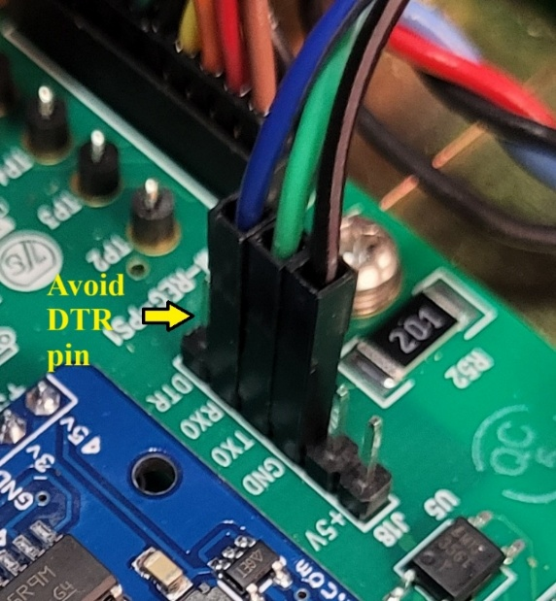
fig. 24

In a separate terminal window, run serial terminal program by typing sudo python3 hypertermdib.py /dev/ttyUSB0. Note that sometimes it may be necessary to use /dev/ttyUSB1 or /dev/ttyUSB2. See 'Setting fan1 duty' scroll on screen. Reset controller board by pressing switch S1 or ac cycle power converter and observe startup text in terminal. Type ctrl-C to stop the terminal program. Get 1-wire temperature sensor ID codes, and update config.txt file on SD card with ID codes. Left sensor is sensor #1, Right sensor is sensor #2. Remove the adapter from J18 when done.

PWM Board Checkout (gate drive boards NOT installed on power amplifier)

- On PWM-Regulator boards, temporarily move jumper shunt from header J8 (J22) to header J3 (J20).
- With bench channel controller board (figure 25) DB44 cables connected to chassis rear panel, turn on power converter channels using the channel controller program.
Note: When all four channels are off. #53 readout (‘Delta PS Mod On/Off Status’) on hyperUDPdib.py will be ‘0b0’.
Turning on channel 1 will cause this register to show ‘0b1’ and controller board D1 will light.
Turning on channel 2 will cause this register to show ‘0b10’ and controller board D2 will light.
Turning on channel 3 will cause this register to show ‘0b100’ and controller board D5 will light.
Turning on channel 4 will cause this register to show ‘0b1000’ and controller board D6 will light.

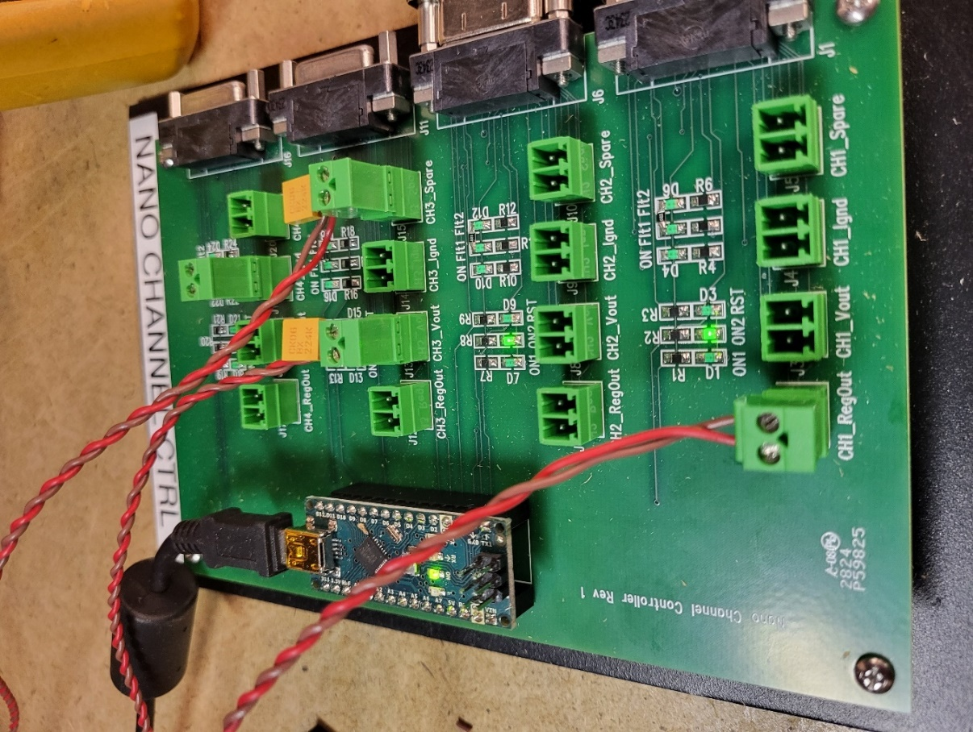
fig. 25 Bench channel control board

Do this in a separate terminal window by typing sudo python3 alsu4chan.py /dev/ttyUSB1.
Note: To turn a channel on, all four ON2 command bits from the PSC or channel controller must be set high first.
- Verify -5 V, -15 V, +5 V, and +15 V power supply levels at test points on power daughterboard (LT-EL-SR-PS-CRR-6301-11) for each PWM-Regulator board. Readings should be within ±0.2 V of nominal.
- Verify that heatsink fan turns on for several seconds then turns off.

- With an oscilloscope verify the following signals on the PWM-Regulator boards:
  - TP7, 250 kHz clock, (located near daughterboard). This can be referenced to ground pins TP4 or TP5.

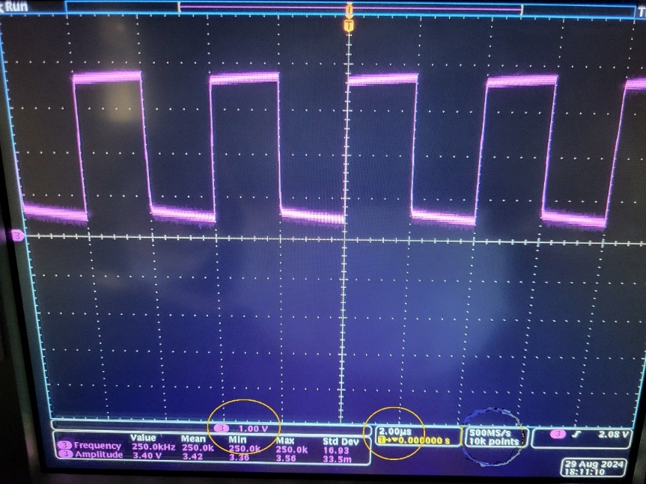
fig. 26

  - Triangle waves at TP22 and TP20. Peak amplitude should be ~4.5 V.

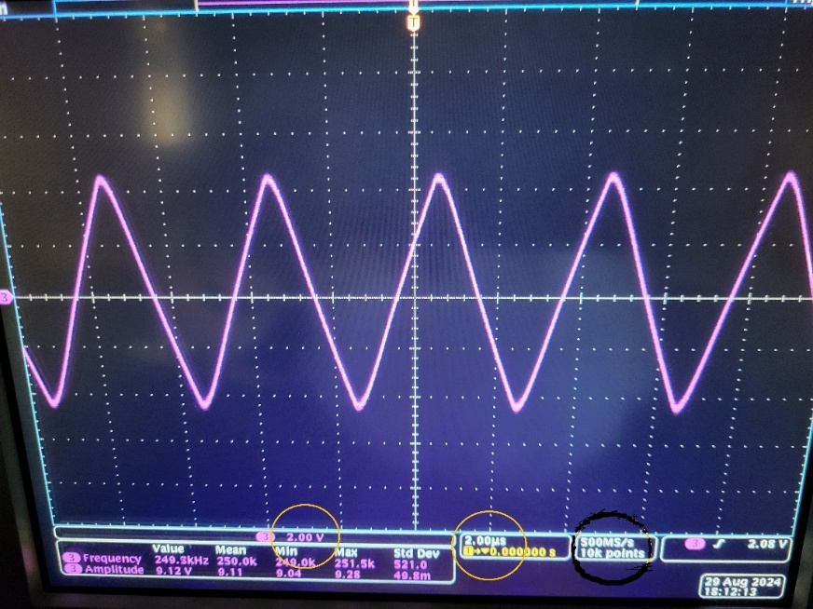
fig. 27

  - Observe PWM signals at C6, C9, C10, C25, C83, C88, C91, and C92.

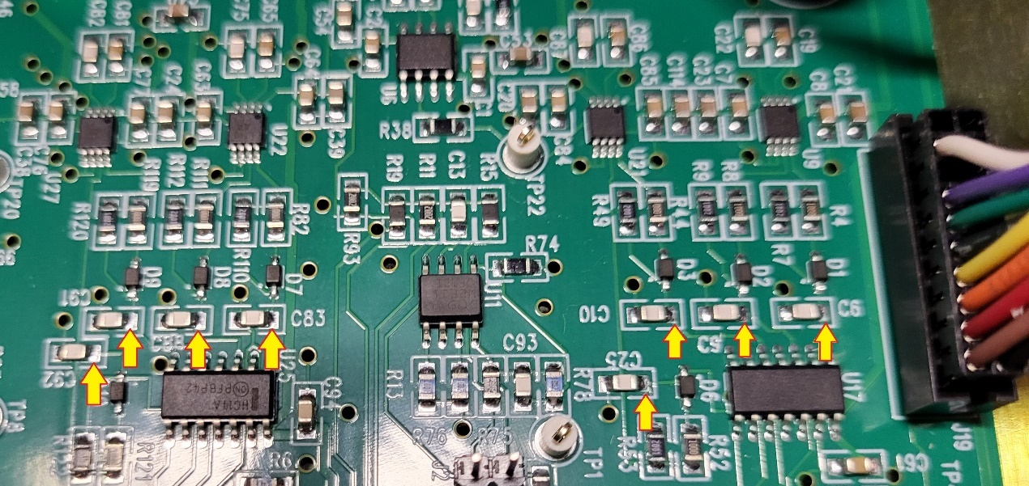
fig. 28

Verify that each of the eight waveforms has a fast rising edge and a slow falling edge.

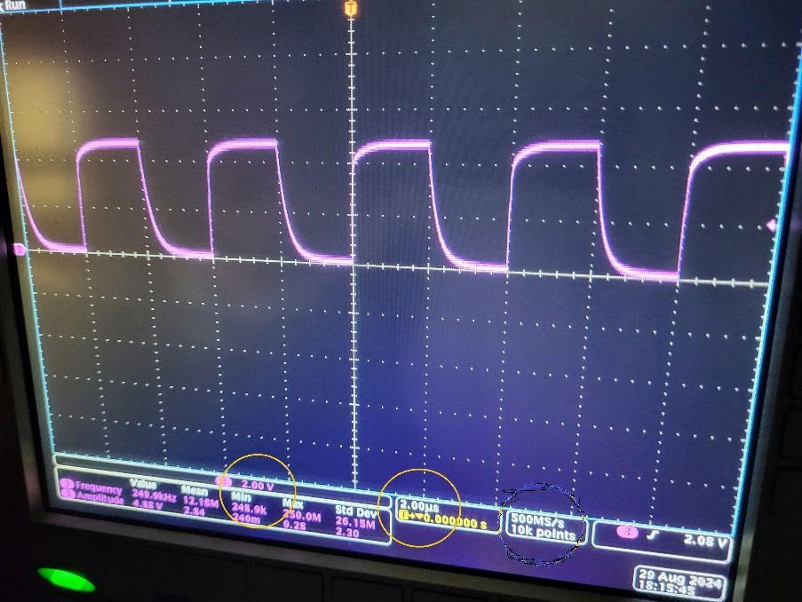
fig. 29

- On each PWM-Regulator board, check signals PWM1 and PWM2 -
- Place probe on PWM1 (J19.14, purple. See right side of figure 28). Probe ground can be attached to TP4 or TP5. Signal trace should be low. Turn 1st channel (CH1 or CH3) off, trace should go high. Turn channel on again. Verify that PWM1- (J19-14, purple) goes from high to low after about 2 s. Do not put hand near fan when turning on.
- Place probe on PWM2 (J19.18, white). Probe ground can be attached to TP4 or TP5. Signal trace should be low. Turn 1st channel (CH1 or CH3) off, trace should go high. Turn channel on again. Verify that PWM2- (J19-18, white) goes from high to low after about 2 s. Do not put hand near fan when turning on.

- On each PWM-Regulator board, check signals PARK1 and PARK2 –
Place probe on PARK1 (J19.12, green). Probe ground can be attached to TP4 or TP5. Signal trace should be low.
Turn 1st channel (CH1 or CH3) off, trace should go high. Turn channel on again. Verify that PARK1 (J19-12, green) goes from high to low after about 4 s. Do not put hand near fan when turning on. Repeat for PARK2 (J19.16, white).
- Connect signal source (the Arbitrary Function Generator) to the NANO CHANNEL CTRL Board (fig. 25) setpoint input for each channel (labeled as CHx_Regout and goes to rear panel Dsub connectors pins 1 and 14).
Connect the two other twisted pairs (with caps on them) into the CH(x)_Vout and CH(x)_Spare sockets for the same channel.
Insert gate drive board extender board into the vacant Power Amp Gate Drive slot 'U2' of the power amplifier board (this is the first of the two channels, either CH1 or CH3. It’s located closest to the front of the chassis as shown in fig. 30) without the gate driver board plugged into the extender board – only the extender board alone.
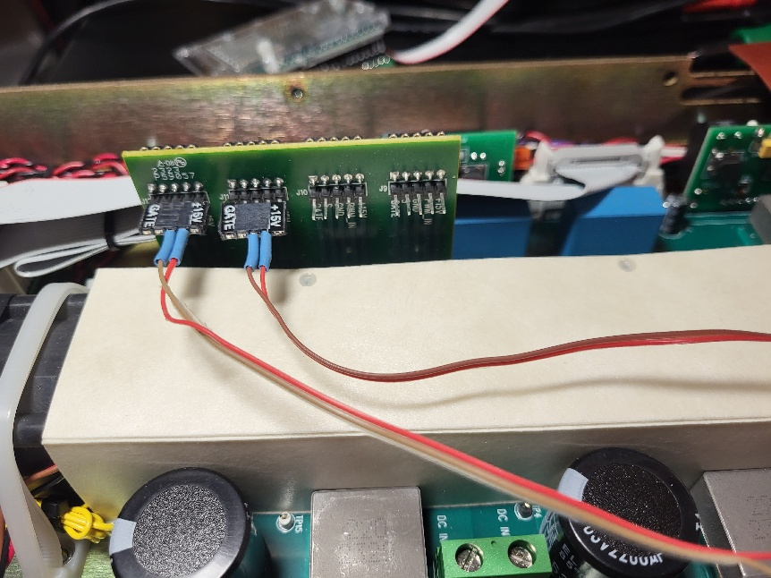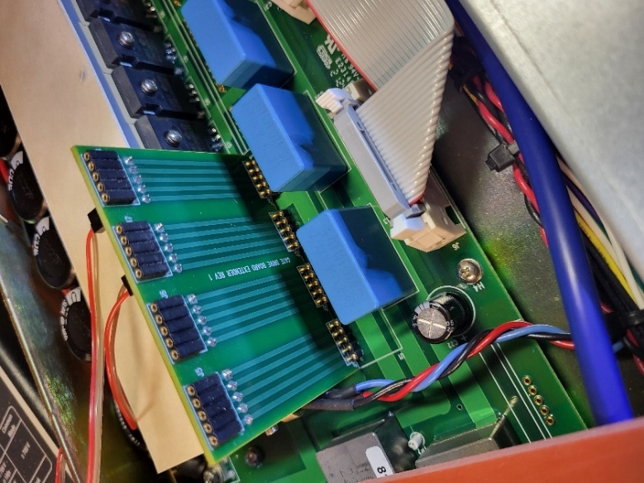
fig. 30 fig. 31

Using two differential oscilloscope probes (fig. 32) connected to CH1 and CH2 of an oscilloscope, attach probes to wire extensions shown in figure 30; positive diff probe goes to red wire and negative differential probe goes to the brown wire. Plug the wire extensions from CH1 into J12 and CH2 into J11: Brown wire to GND pin; red wire to PWM_IN pin.
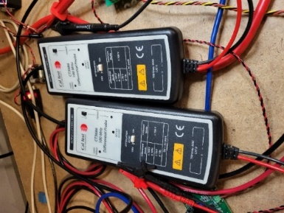
fig. 32

In terminal window on workstation, type sudo python3 sweep1.py. Observe complementary PWM signals at test point header pins (PWM_IN, GND) on gate drive board extender. The pulse widths for the yellow and blue traces (inputs from the function generator to CH(x)_RegOut) should alternately expand and contract while the DC level (green trace) alternates between +5V and -5V, (with the DC level at 0v, the pulse width at both channels should be the same).
There must always be a gap present between the CH1 (yellow) and CH2 (blue) traces as shown in the pictures below – if not, this test failed.
If passed test, move the wire extensions to J10 and J9 of the extender board and run sweep1 again.
If passes, turn off channel 1. Making sure that channel 2 is also off move the extender board to the set of sockets on toward the rear of the power amp board (labelled 'U1', this is for the 2nd channel - either CH2 or CH4), move the wire extensions back to J12 and J11. Move the twisted pair wires on the NANO CHANNEL CTRL Board to the CH2_RegOut, CH2_Ignd and CH2_Spare sockets. Power up CH2 and run sweep1.
If passes, move wire extensions to J10 and J9 on the extender board and run sweep1 again.
If passes, turn off CH2. Move extension board to the #2 power amplifier board and repeat for both of its channels.

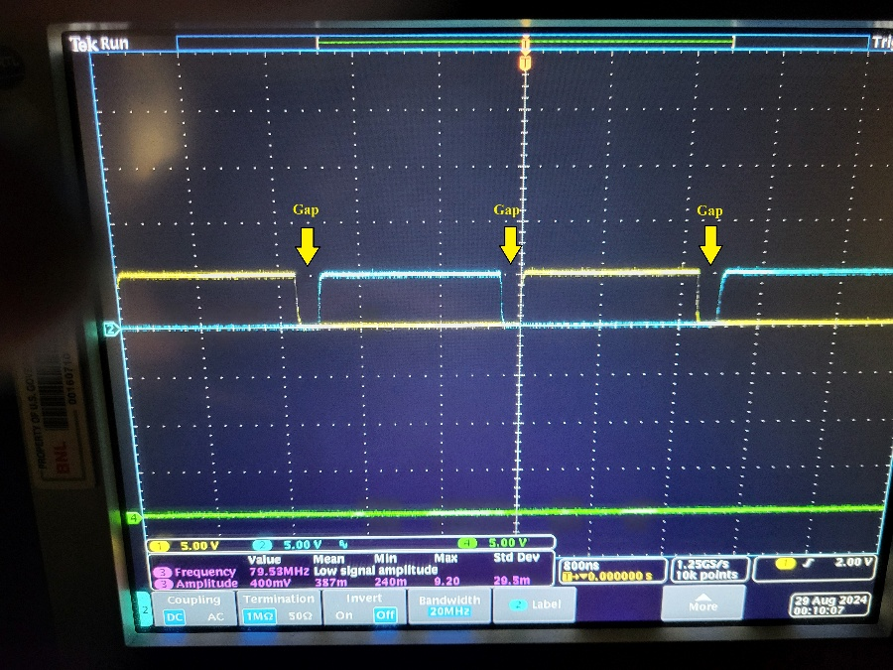

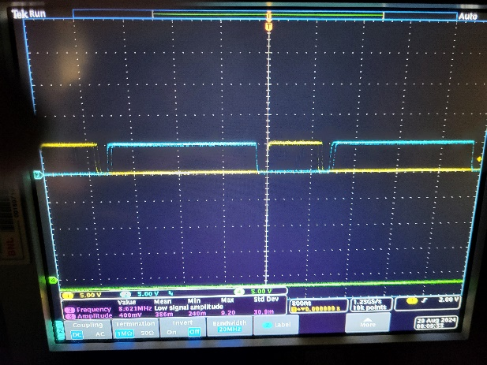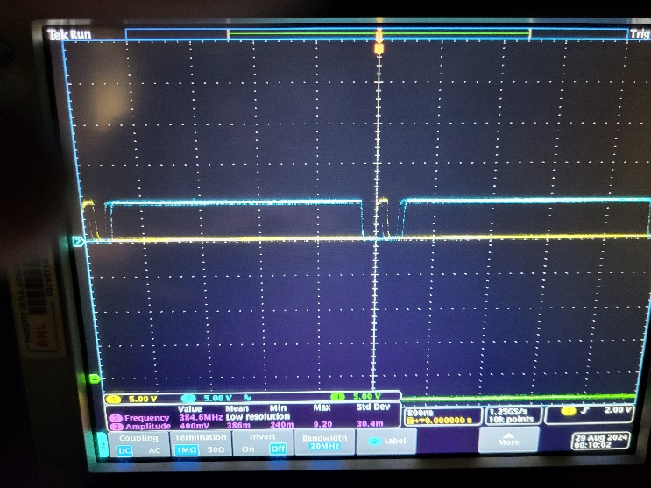
fig. 33

- Turn off power converter channels. Turn off AC power to chassis. Remove the extender board from the gate driver board slot.

Power Amplifier Board Checkout
- Measure Rgs resistance at each SiCFET between pins 3 and 4. Verify 10 kΩ reading.
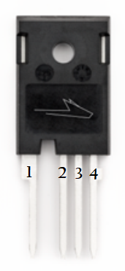
fig. 34

- Install both gate drive boards into each power amplifier board.
- Install fuse F3 into power amplifier board power daughterboard.
- Connect a pair of multimeter clip leads across the unpopulated F1 fuse holder terminals on the power amplifier power daughterboard. Set DVM for ammeter function, use ADC (not mADC).

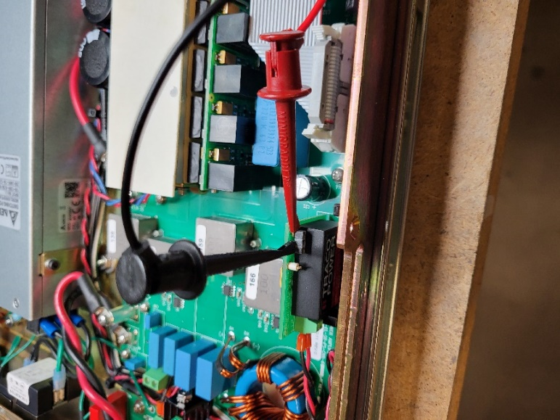
fig. 35

- Apply AC power to chassis. Turn on the channel and measure current with an ammeter.
- Verify that 15 V current draw is approximately 0.15 - 0.25 A.
- Install fuse F1 into power daughterboards (LT-EL-SR-PS-CRR-6301-21).
- On PWM-Regulator boards, move jumper shunt from header J3 (J20) back to header J8 (J22).
- Turn on chassis AC power, and turn on each power converter channel. Verify +15 V power supply level at testpoint TP2 on power daughterboard (LT-EL-SR-PS-CRR-6301-21) for each power amplifier board.
- Connect signal source to the Bench Channel Controller Board setpoint input for each channel labeled as CHx_Regout for each channel to be tested. On #1 Power Amplifier Board, locate H-bridge outputs TP5(+) and 6(-) for CH1 or CH3 (fig. 36) and TP7(+) and 8(-) for CH2 or CH4 (fig. 37).
Connect differential probe for oscilloscope CH1 across TP7 and 8 and differential probe for scope CH2 across TP5 and 6, observing red/+ and black/- polarity. Turn on power converter channel.

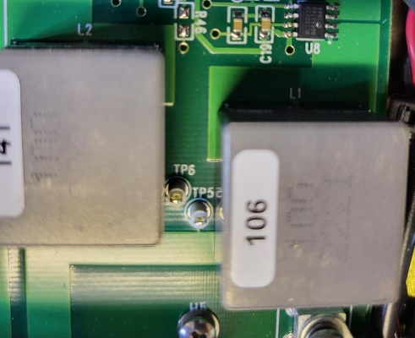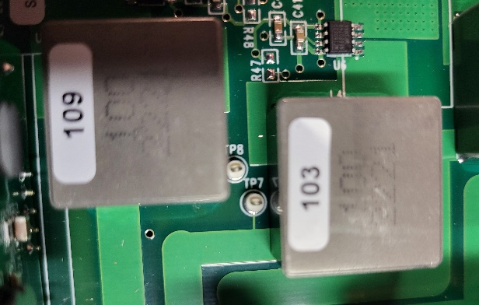
fig. 36 fig. 37

In terminal window on workstation, type sudo python3 sweep2.py. Verify proper output pulses as control input is varied as shown in figure 38. The CH1 (yellow) waveform goes positive and its pulse width widens as the DC level (green) reaches +5V; then goes negative and pulse width widens as DC level reaches -5V.

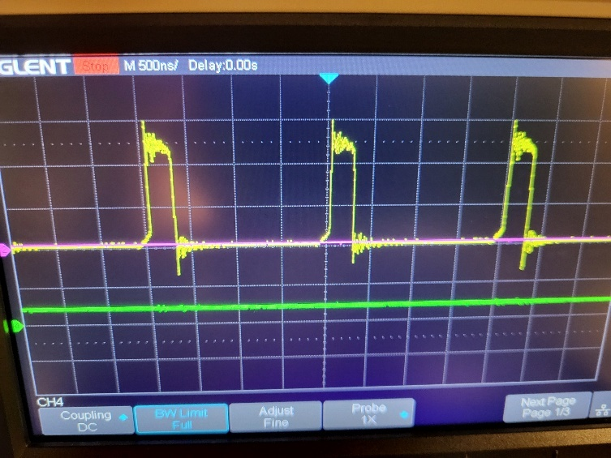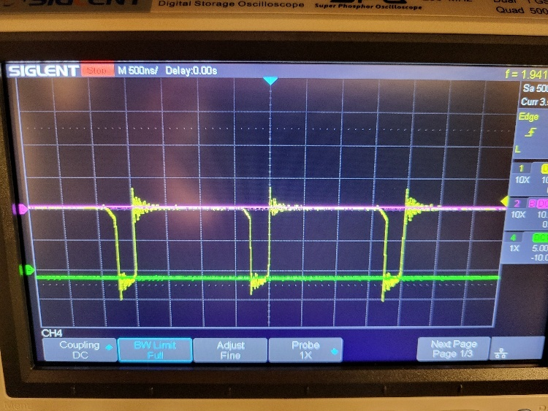
fig. 38
When the test is done, move signal twisted pair wires over to 'CH2_Regout' and swap the differential scope probes so that scope CH1 probe is connected to TP5 and 6 and CH2 probe is now across TP7 and 8. Run sudo python3 sweep2.py again, you should see the same signals as shown in figure 38 again. When done, repeat for CH3 and CH4 on the other Power Amp board.
D. External Tests (chassis top cover on, no load):
- Ignd readback ohmmeter verification. With both channels turned off, and using connector labeled CHx_Ignd (where x is the channel being tested) on bench channel controller board, verify:
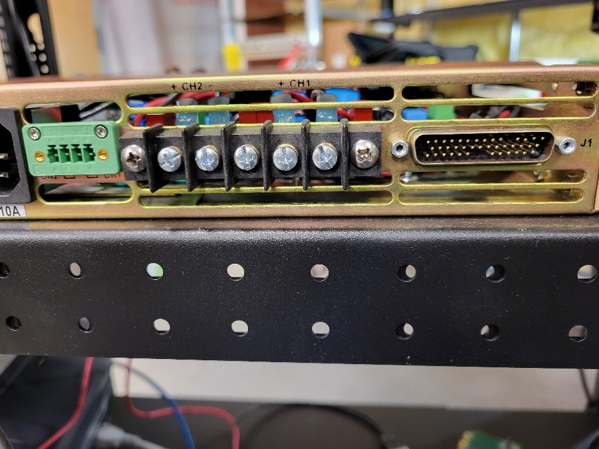
fig. 39 Rear panel

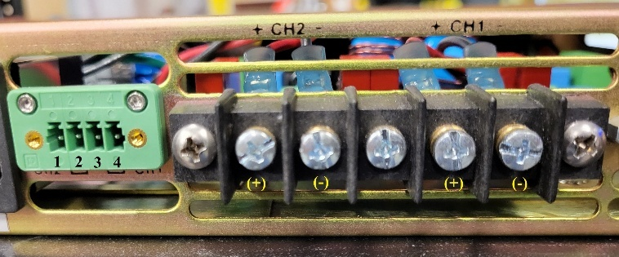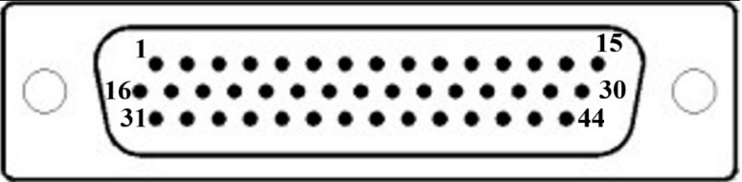
fig. 40 Jumper block and output terminal block fig. 41 44-pin DSUB connector

  - CH1/3 (-) output terminal to rear panel jumper block terminal 4 measures 100 Ω.
  - CH1/3 (-) output terminal to HD44 connector pin 3 measures short
  - Jumper block terminal (1 and?) 3 measures short to chassis
  - HD44 pin 19 measures short to chassis
  - CH2/4 (-) output terminal to rear panel jumper block terminal 2 measures 100 Ω.
  - CH2/4 (-) output terminal to HD44 connector pin 13 measures short
  - Jumper block terminal 1 (and 3?) measures short to chassis
  - HD44 pin 28 measures short to chassis

- On bench channel controller board, verify that ON readback signal lights up high when channel is turned on (rear panel DB25 connector pins 20,24). D4 = CH1, D10 = CH2, D16 = CH3, D22 = CH4.
- Turn on channel with ON2 signal disabled to produce an ON fault. On bench channel controller board, verify that Fault1 signal lights up when channel is turned on (rear panel DB25 connector pins 21,24).
Note: It usually takes 5 to 7 seconds for the fault LED to light.
- On bench channel controller board, verify that Fault2/Heartbeat signal is pulsing once per second (rear panel DB25 connector pins 22,24).

Steps 63 to 66
Setup –
Place a DMM next to the AWG (Arbitrary Waveform Generator). Use one pair of banana – banana leads to connect the DMM to the 4CH output board shown below. This will be used for steps 63 – 64.
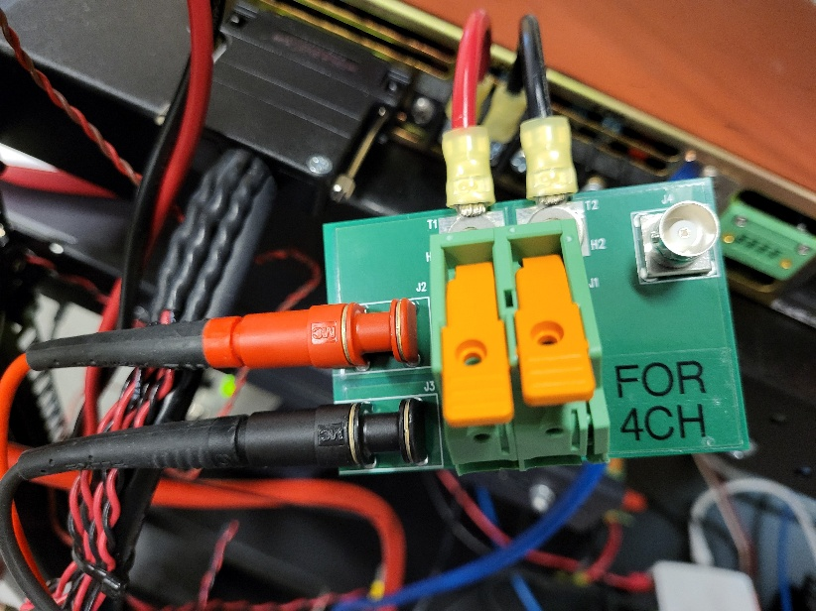
fig. 42

To do steps 65 and 66, disconnect the banana-banana leads from the DMM and connect a red and black twisted pair (TP) with banana plugs on either end labeled 'CH_Vout' between the DMM and CH3 of the low signal oscilloscope (under the keyboard) from the oscilloscope.
For step 66, just move the TP wires on the low-signal scope from CH3 (CH(x)_Vout) to CH4 (CH(x)_Spare).
- Connect the T1 (+) and T2 (-) leads from the 4CH output board to CH1 of the chassis terminal block.
- Move the three sets of TP wires to CH1_RegOut, CH1_Vout and CH1_Spare on the channel controller board.
- With the chassis powered up, turn on CH1.
- Manually set the AWG to each of the voltage outputs in the table below. Toggle the generator output using the ‘On/Off’ button.

step | AWG voltage | Output source | DVM reading
63 | 2.53v | 4CH output board | 9.5 to 9.6v
63 | -2.53v | 4CH output board | -9.5 to -9.6v
64 | 5.00v | 4CH output board | 18.6 to 19.0v
64 | -5.00v | 4CH output board | -18.6 to -19.0v

- Disconnect the 4CH output board leads from the DMM. Plug in the banana plugs of the 'CH_Vout' TP wires to the DMM on one end and CH3 of the low-signal oscilloscope on the other. Do the following two readings
step | AWG voltage | Output source | DVM reading
65 | 5.00v | CH(x)_Vout | -9.85 to -10.15v
65 | -5.00v | CH(x)_Vout | 9.85 to 10.15v

f. Disconnect the 'CH_Vout' leads from CH3 at the low-signal oscilloscope-end and plug them into CH4, which is the CH(x)_Spare signal to check the 24V bus readback signal -

step | AWG voltage | Output source | DVM reading
66 | (n/a) | CH(x)_Spare | 4.7 to 4.9v

g. Turn off CH1. Unplug the 'CH_Vout' TP leads from the DMM and the scope and return the leads from the
4CH output board to the DVM.
h. Return the Arbitrary Waveform Generator's output to 0 V. Turn off BPC channel 1. On the bench channel controller
board, move the waveform generator connector from 'CH1_' to 'CH2_'. Turn on BPC channel 2 then repeat steps
65. through 68.

Repeat steps a through g for the remaining three channels. If they pass, steps 63 to 66 can be checked off as completed. When done ensure that the twisted pair 'CH_Vout' wires are removed from the small signal oscilloscope.
67. Connect Load 1 to channel 2. Turn on channel 2. Turn off channels 1, 3 and 4. Dial up signal generator voltage setpoint for a current of 10 A. Observe heatsink temperature readbacks in UPD housekeeping data. Verify that channels 1 and 2 temperatures increase. If channels 3 and 4 temperatures increase, turn off channel 2, turn off AC voltage to the chassis and swap 1-wire temperature sensor ID codes in the config.txt file on the SD card.

E. Performance Tests (chassis top cover on, with loads)
Ensure that channel 1 output terminals are still connected to 4CH output board, (figure 42) and that 10 AWG red/black twisted-pair wires are connected between its J1 terminals and the resistive '4-CHANNEL LOAD', (shown in figure 43 below entering the terminal block from the right and going to the outer terminals. The inner pair of black wires go to a 20mH/30A reactor coil labeled ‘LOAD 2’ at the bottom of the rack). Ensure that the toggle switch on the load is in its down position for normal resistive load.
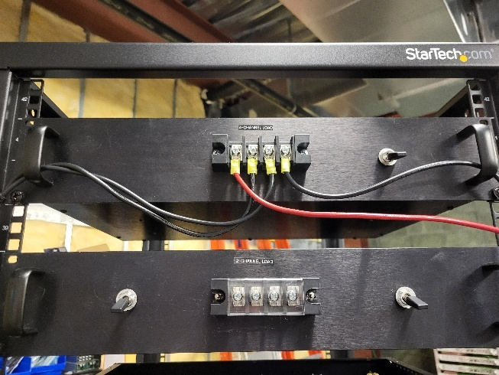
fig. 43
On the 4CH output board, the J2 and J3 jacks on the left goes to the differential oscilloscope probes for CH 1.
BNC jack J4 should have a coax cable connected between it and CH1 of the low-signal oscilloscope beneath the keyboard on the test rack. This same oscilloscope should be connected to the bench channel control board as follows -
Scope CH3 to bench channel control board CH(x)_Vout
Scope CH4 to bench channel control board CH(x)_Spare
(where ‘x’ is the channel to be tested).
In terminal window on workstation, type sudo python3 bpc_test.py to run python program that will guide you through performance tests.

Tests are -
68. Wideband noise measurement: Current output should be 5 A.
69. Step response measurement
68b. Common mode noise measurement: Remove negative lead from output board. Attach alligator clip to lead
and connect lead to chassis. Current output should be 5 A.
Narrowband noise measurement: Disconnect negative lead from chassis and alligator clip. Reconnect
negative lead to output board.
70. Energy extraction measurement: (Ignore steps a through e, hit Enter). Verify 8 to 9 amp reading at ‘Hall
sensor’ on hyperUDPdib.py for channel under test - then turn off channel.
71. Max V and I measurement: Make sure channel has been turned back on. Have a DMM ready to measure DC
voltage and an ammeter to measure DC current. Ignore steps a through c; verify on hyperUDPdib.py
readout #53 that channel is still be ON. Hit Enter then take voltage and current readings and record them on
the test sheet.

For channels 1 and 2, ‘Heatsink temp1’ on hyperUDPdib.py (readout #45) should be higher at around 30 - 35 degrees than the ‘Heatsink temp2’ readout at #46 which should be around 27 degrees. The opposite is true when channels 3 or 4 are tested.

At end of test when it asks 'Copy files from /home/dib/_temp/ to /home/dib/BPC-XXX-XXX/? (y/n)', press 'y'. See 'files copied'

72. OVC Interlock
- With all of the output channels off, connect the 4CH output board (figure 42) to CH1 output terminals.
- On the '4-CHANNEL LOAD' (figure 43), flip the switch to its up position for low-resistance load.
- Connect the twisted pair output from the arbitrary function generator to the appropriate ‘CH(x)_RegOut’ jack on the NANO CHANNEL CTRL board.
- Make sure hyperUDPdib.py is running.
- On channel control window, enable the channel to be tested.
On UDP readout #53 you should see ‘0b1’ for channel 1 ('0b10' for CH2, '0b100' for CH3 or '0b1000' for CH4).
On readout #54 ('Fault status'), you should see 0xΦ0000, (where the bit at position Φ is toggling between 1 and 0).
- On the arbitrary function generator, enable output, ('On/Off'). Slowly increase the voltage level at the function generator and observe the current readouts at the UDP window at readouts #2 and #3 ('Hall sensor 1' and 'Hall sensor 2' for CH1, sensors 3 and 4 for CH2, 5 and 6 for CH3 and 7 and 8 for CH4). At 3v input, output should be around 10A. Continue to monitor the 'Hall sensor' output currents and 'Fault status' on UDP readout while slowly increasing the input voltage until the current passes 12 to 14 amps and the overcurrent protection (OVC) should trip off the converter.
On the UDP, see readout #53 change from '0b1' to ‘0b0’ and #54 '0xΦ00000' readout should change to either ‘0xΦ0011’ for channel 1 (‘0xΦ0022’ for channel 2, ‘0xΦ0044’ for channel 3, ‘0xΦ0088’ for channel 4). The fan speed should slow down and the 'Flt1' LED on the Bench Channel Control Board should light.
Reduce input voltage to 0v and reset CH.1 (input a '17' on ALSU4CHAN.py screen).
- Repeat the above steps with the function generator outputting a negative voltage.
- Repeat steps 69.1 and 69.3 through 69.7 for the remaining three channels.

73. Move test data files from ~/_temp directory to directory with filename model_serial.
Email data to offline host by typing sudo ./tar1.sh.
End of Test

